Programing Fundamental

3rd Assignment

Session: 1E

Name:

Sabir Hussain

Roll no:

BCSM-f19-262

Pro: Hafiz Muhammad Zahid

1. If the lengths of the sides of a triangle are denoted by a, b, and c, then area of triangle is given by

area = $\sqrt{s\left(s-a\right)\left(s-b\right)\left(s-c\right)}$

where

S = (a + b + c) / 2

Write a function to calculate ‘area’ of a triangle according to above scenario. The prototype of this function is double area (double a, double b, double c);

**Program:**

#include<iostream>

#include<conio.h>

#include<math.h>

using namespace std;

double area (double a, double b, double c);

int main ()

{

double a, b, c;

cout<<"\t\t Area of a Triangle \n";

cout<<endl;

cout<<"Enter the lengths of the sides 'a' = ";

cin>>a;

cout<<"Enter the lengths of the sides 'b' = ";

cin>>b;

cout<<"Enter the lengths of the sides 'c' = ";

cin>>c;

cout<<endl<<endl<<endl;

cout<<"Area of Triangle = "<<area (a, b, c) <<" (sq. unit)";

getch ();

return 0;

}

double area (double s1, double s2, double s3)

{

double s, ans;

s=(s1+s2+s3)/2.0;

ans=sqrt(s*(s-s1) * (s-s2) * (s-s3));

return ans;

}

**Output console:2**

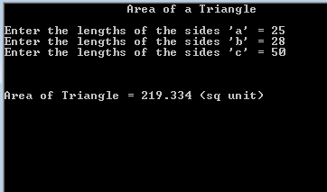

**Output console:1**

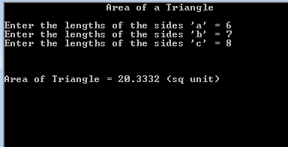

1. **Write a function to draw following:**

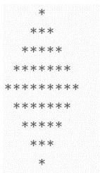

**Program:**

**#include<iostream>**

**#include<conio.h>**

**#include<math.h>**

**using namespace std;**

**void daimand_upper (void);**

**void daimand_lower (void);**

**int main ()**

**{**

**daimand_upper ();**

**daimand_lower ();**

**getch ();**

**return 0;**

**}**

**void daimand_upper(void)**

**{**

**int v=1;**

**for (int j=1; j<=5; j++)**

**{**

**for (int k=4; k>=j; k--)**

**{**

**cout<<" ";**

**}**

**for (int l=1; l<=v; l++)**

**{**

**cout<<"*";**

**}**

**cout<<endl;**

**v+=2;**

**}**

**}**

**void daimand_lower(void)**

**{**

**int v=7;**

**for (int j=1; j<=4; j++)**

**{**

**for (int k=1; k<=j; k++)**

**{**

**cout<<" ";**

**}**

**for (int l=1; l<=v; l++)**

**{**

**cout<<"*";**

**}**

**cout<<endl;**

**v-=2;**

**}**

**}**

**Output console:**

